COIT20247

**Database Design and Development**

Term – 1, 2020

Assignment-1

**Lecturer/Tutor:**

Annie Ding

**Prepared By:**

Bishal Budhathoki

12116421

**Table of Contents:**

**Entity Relationship Diagram:** 3

**Assumptions/ Business Rules:** 4

**Data Dictionary:** 5

**Acknowledgment** 13

# **Entity Relationship Diagram:**

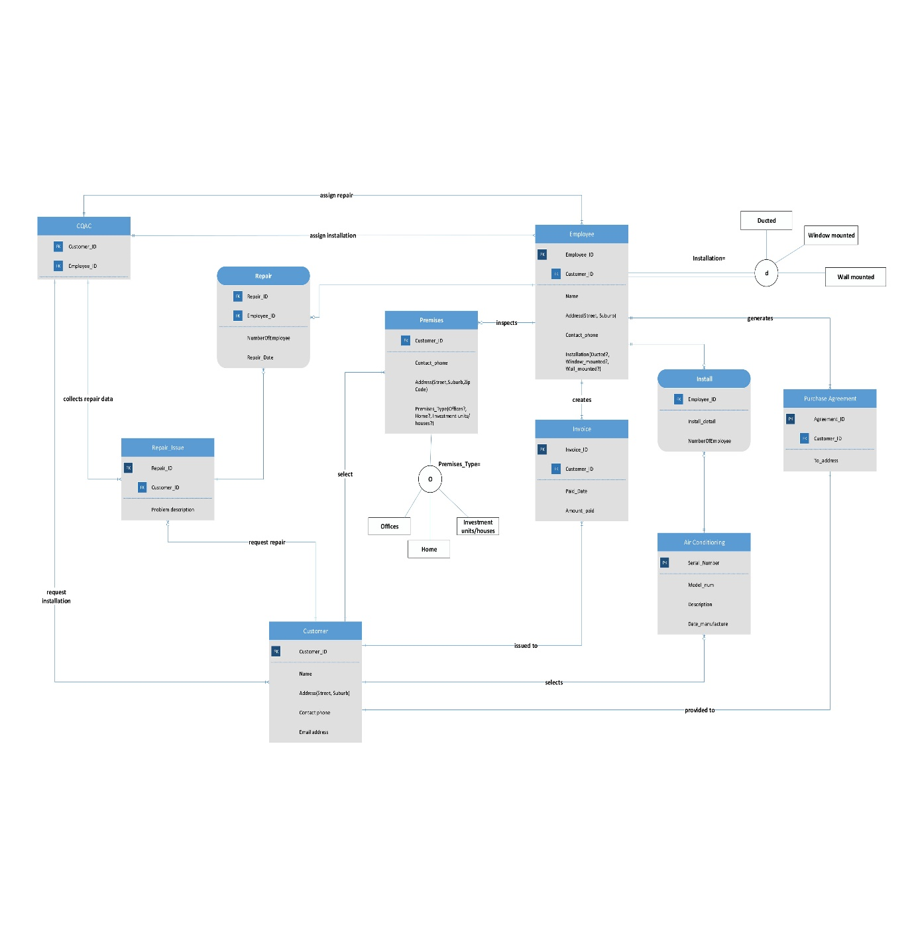

**Note:** Please zoom in the image for higher details.

The above provided image is the ER diagram representation of CQ Air conditioning services (CQAC).

# **Assumptions/ Business Rules:**

From the case study of CQ Air conditioning services (CQAC), there are some assumptions made. They are listed below:

1. Customer on the first hand will provide premises information to the company.
2. Employee provide option of selecting the installation type to the customer after company assign the task to the employee.
3. Every request of installation/repair needs to go through CQAC then it is passed to employee.
4. One employee can visit multiple premises for inspection.
5. From the case study, it is assumed that single employee is assigned for repair and zero or more employee is assigned for installation.
6. No employee will perform repair or installation until assigned by CQAC.
7. Customer always first communicates with CQAC then CQAC assigns task. Then either repair, or installing or both activities is done.
8. Invoices are generated after finishing the repair or instalment.
9. Purchase agreement is generated after product to install is selected by customer.
10. Repair issue contains the issue which is then obtained by CQAC only.
11. 40% of total amount is the minimum required balance to pay in the first invoice generated.
12. Only one employee will generate invoice and purchase agreement.
13. Only one employee will inspect the premises.
14. Employee provide exactly one options for mounting.

# **Data Dictionary:**

|  |  |  |  |  |  |  |  |  |  |
| --- | --- | --- | --- | --- | --- | --- | --- | --- | --- |
| **Entity name** | **Entity Definition** | **Attribute name** | **Attribute Definition** | **Data types** | **Length** | **Primary key** | **Nullable** | **Unique** | **Min/Max value** |
| Employee | An employee is someone who work in CQAC | Employee_ID | For unique identification of employee records | integer | 10 | True | False | True | N/A |
|  |  | Customer_ID | For unique identification of customer records | integer | 10 | False | False | False | N/A |
|  |  | Name | Name of the employee | varchar | 255 | False | False | False | N/A |
|  |  | Street | Street for the address of employee | varchar | 255 | False | True | False | N/A |
|  |  | Suburb | Street for the address of employee | varchar | 255 | False | True | False | N/A |
|  |  | Contact phone | Phone number to contact of employee | number | 10 | False | True | False | N/A |
|  |  | Ducted | Type of installation | varchar | 5 | False | False | False | N/A |
|  |  | Window mounted | Type of installation | varchar | 5 | False | False | False | N/A |
|  |  | Wall mounted | Type of installation | varchar | 5 | False | False | False | N/A |

|  |  |  |  |  |  |  |  |  |  |
| --- | --- | --- | --- | --- | --- | --- | --- | --- | --- |
| **Entity name** | **Entity Description** | **Column name** | **Column Description** | **Data types** | **Length** | **Primary key** | **Nullable** | **Unique** | **Min/Max value** |
| CQAC | Name of company is CQAC | Employee_ID | For unique identification of employee records | integer | 10 | False | False | False | N/A |
|  |  | Customer_ID | For unique identification of customer records | integer | 10 | False | False | False | N/A |

|  |  |  |  |  |  |  |  |  |  |
| --- | --- | --- | --- | --- | --- | --- | --- | --- | --- |
| **Entity name** | **Entity Description** | **Column name** | **Column Description** | **Data types** | **Length** | **Primary key** | **Nullable** | **Unique** | **Min/Max value** |
| Repair_issue | Customer might request for repair of AC | Repair_ID | For unique identification of repair records | Integer | 10 | True | False | True | N/A |
|  |  | Customer_ID | For unique identification of customer records | integer | 10 | False | False | True | N/A |
|  |  | Problem description | For understanding the issue better | varchar | 255 | False | False | False | N/A |

|  |  |  |  |  |  |  |  |  |  |
| --- | --- | --- | --- | --- | --- | --- | --- | --- | --- |
| **Entity name** | **Entity Description** | **Column name** | **Column Description** | **Data types** | **Length** | **Primary key** | **Nullable** | **Unique** | **Min/Max value** |
| Invoice | Commercial document issued by CQAC to customer | Invoice_ID | For unique identification of invoice records | integer | 10 | True | False | True | N/A |
|  |  | Date paid | Full/ partial amount paid date | Date | 10 | False | False | False | N/A |
|  |  | Amount paid | Full / partial amount paid | Integer | 10 | False | True | False | >40% of total amount  <Full amount |
|  |  | Customer_ID | For unique identification of customer records | Integer | 10 | False | False | False | N/A |
|  |  | Repair_ID | For unique identification of repair records | Integer | 10 | False | True | False | N/A |

|  |  |  |  |  |  |  |  |  |  |
| --- | --- | --- | --- | --- | --- | --- | --- | --- | --- |
| **Entity name** | **Entity Description** | **Column name** | **Column Description** | **Data types** | **Length** | **Primary key** | **Nullable** | **Unique** | **Min/Max value** |
| Air Conditioning | AC that customer request | Serial_Number | For unique identification of AC records | integer | 10 | True | False | True | N/A |
|  |  | Model | Describes what it consists | integer | 10 | False | False | False | N/A |
|  |  | Description | Describes the model and features | varchar | 255 | False | True | False | N/A |
|  |  | Date_manufacture | Manufactured date of AC | Date | 10 | False | False | False | N/A |

|  |  |  |  |  |  |  |  |  |  |
| --- | --- | --- | --- | --- | --- | --- | --- | --- | --- |
| **Entity name** | **Entity Description** | **Column name** | **Column Description** | **Data types** | **Length** | **Primary key** | **Nullable** | **Unique** | **Min/Max value** |
| Purchase Agreement | Defines the purchase agreement | Agreement_ID | For unique identification of product purchased | Integer | 10 | True | False | True | N/A |
|  |  | Customer_ID | For unique identification of customer records | Integer | 10 | False | False | True | N/A |
|  |  | To_address | For address of delivery of product | Varchar | 255 | False | False | False | N/A |

|  |  |  |  |  |  |  |  |  |  |
| --- | --- | --- | --- | --- | --- | --- | --- | --- | --- |
| **Entity name** | **Entity Description** | **Column name** | **Column Description** | **Data types** | **Length** | **Primary key** | **Nullable** | **Unique** | **Min/Max value** |
| Customer | Defines the buyer or service user | Customer_ID | For unique identification of customer records | Integer | 10 | True | False | True | N/A |
|  |  | Name | Customer name | Varchar | 255 | False | False | False | N/A |
|  |  | Street | Street customer lives in | Varchar | 255 | False | False | False | N/A |
|  |  | Suburb | Suburb customer lives in | Varchar | 255 | False | False | False | N/A |
|  |  | Contact_phone | Customer phone number | Integer | 10 | False | False | False | N/A |
|  |  | Email address | Email address of customer | Varchar | 255 | False | False | False | N/A |
|  |  | Offices | Premises address option | Varchar | 255 | False | False | False | N/A |
|  |  | Home | Premises address option | Varchar | 255 | False | False | False | N/A |
|  |  | Investment units/houses | Premises address option | Varchar | 255 | False | False | False | N/A |

|  |  |  |  |  |  |  |  |  |  |
| --- | --- | --- | --- | --- | --- | --- | --- | --- | --- |
| **Entity name** | **Entity Description** | **Column name** | **Column Description** | **Data types** | **Length** | **Primary key** | **Nullable** | **Unique** | **Min/Max value** |
| Install | This describes installing AC activity (Associative) | Employee_ID | For unique identification of employee records | integer | 10 | False | False | True | N/A |
|  |  | Install_detail | Describes condition for installing | varchar | 255 | False | False | False | N/A |
|  |  | NumberOfEmployee | Describes number of employed | int | 10 | False | False | False | N/A |

|  |  |  |  |  |  |  |  |  |  |
| --- | --- | --- | --- | --- | --- | --- | --- | --- | --- |
| **Entity name** | **Entity Description** | **Column name** | **Column Description** | **Data types** | **Length** | **Primary key** | **Nullable** | **Unique** | **Min/Max value** |
| Repair | This describes repairing of AC activity (Associative) | Employee_ID | For unique identification of employee records | integer | 10 | False | False | True | N/A |
|  |  | Repair_ID | Describes condition for installing | integer | 10 | False | False | True | N/A |
|  |  | NumberOfEmployee | Describes number of employed | varchar | 10 | False | False | False | N/A |
|  |  | Repair_Date | Describes when repair will be done | integer | 10 | False | False | False | N/A |

|  |  |  |  |  |  |  |  |  |  |
| --- | --- | --- | --- | --- | --- | --- | --- | --- | --- |
| **Entity name** | **Entity Definition** | **Attribute name** | **Attribute Definition** | **Data types** | **Length** | **Primary key** | **Nullable** | **Unique** | **Min/Max value** |
| Premises | Describes where installation is required | Customer_ID | For unique identification of customer records | integer | 10 | False | False | True | N/A |
|  |  | Contact_phone | For unique identification of customer contact number | integer | 10 | False | False | False | N/A |
|  |  | Street | Street for the address of employee | varchar | 255 | False | True | False | N/A |
|  |  | Suburb | Street for the address of employee | varchar | 255 | False | True | False | N/A |
|  |  | ZipCode | Phone number to contact of employee | number | 10 | False | True | False | >0001  <9999 |
|  |  | Offices | Type of premises | varchar | 255 | False | False | False | N/A |
|  |  | Home | Type of premises | varchar | 255 | False | False | False | N/A |
|  |  | Investment units/houses | Type of premises | varchar | 255 | False | False | False | N/A |

# **Acknowledgment**

This assignment was completed using only the COIT20247 unit materials and lecturer/ tutor Annie Ding help during tutorial classes. Various slides and text book material provided in moodle has been used for this assignment.

Bishal Budhathoki,

12116421